**Array assignment of c programing .**

**Student Name : محمد ابراهيم محمد السعيد ابراهيم**

**Id : 18011342**

**Section or lab : 8**

**Electrical communication engineering.**

**Code 1:**

**#include <stdio.h>**

**#include <stdlib.h>**

**void find_date(int day_year, int year , int *day , int *month);**

**int main()**

**{ int day , month , day_year , year , o;**

**day=0;month=0;**

**printf("please enter the year number\n");**

**scanf("%d",&year);**

**printf ("please enter the day_year number\n");**

**scanf ("%d",&day_year);**

**// check if it is a leap year**

**if (year%4==0){**

**if (year%400==0){**

**printf("year %d is a leap year\n",year);**

**o=1;**

**}**

**else if (year%100==0){**

**printf("year %d is not a leap year\n",year);**

**o=0;**

**}**

**else {**

**printf("year %d is a leap year\n",year);**

**o=1;**

**}**

**}**

**else {**

**printf("year %d is not a leap year\n",year);**

**o=0;**

**}**

**//check that he entered a real day_year number**

**while (day_year){**

**if (o==0){**

**if (1<day_year && day_year<=365)break;**

**else {**

**printf ("please enter the day_year number from 1 to 366 again\n");**

**scanf ("%d",&day_year);**

**}**

**}**

**else if (o==1){**

**if (1<=day_year && day_year<=366)break;**

**else {**

**printf ("please enter the day_year number from 1 to 366 again\n");**

**scanf ("%d",&day_year);**

**}**

**}**

**}**

**find_date(day_year,year,&day,&month);**

**printf("the date is %d/%d/%d \n",day,month,year);**

**return 0;**

**}**

**void find_date(int day_year, int year , int *day , int *month)**

**{**

**int o,i,k;**

**i=0;**

**// check again that it is a leap year or not**

**if (year%4==0){**

**if (year%400==0) o=1;**

**else if (year%100==0) o=0;**

**else o=1;**

**}**

**else o=0;**

**int months [12] ={31,28,31,30,31,30,31,31,30,31,30,31};**

**// when it is a leap year month [1]= 29 days and if it is not it will be 28 days**

**if (o==1) months[1]=29;**

**else if (o==0) months[1]=28;**

**while(day_year>0){**

**day_year=day_year-months[i];**

**i=i+1;**

**}**

**if(i==1 || i==3 || i==5 || i==7 || i==8 || i==10 || i==12 ) k= day_year + 31;**

**else if(i==4 || i==6 || i==9 || i==11 ) k= day_year + 30;**

**else if(i==2) k= day_year + months[1];**

**\*day =k;**

**\*month =i;**

**}**

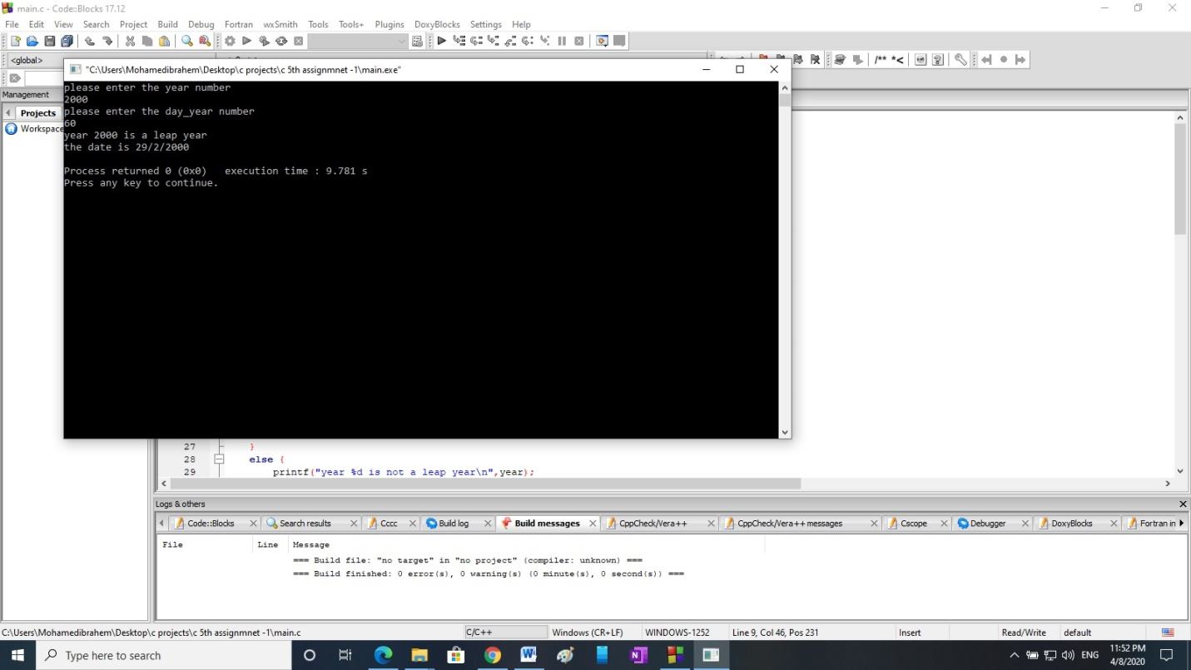

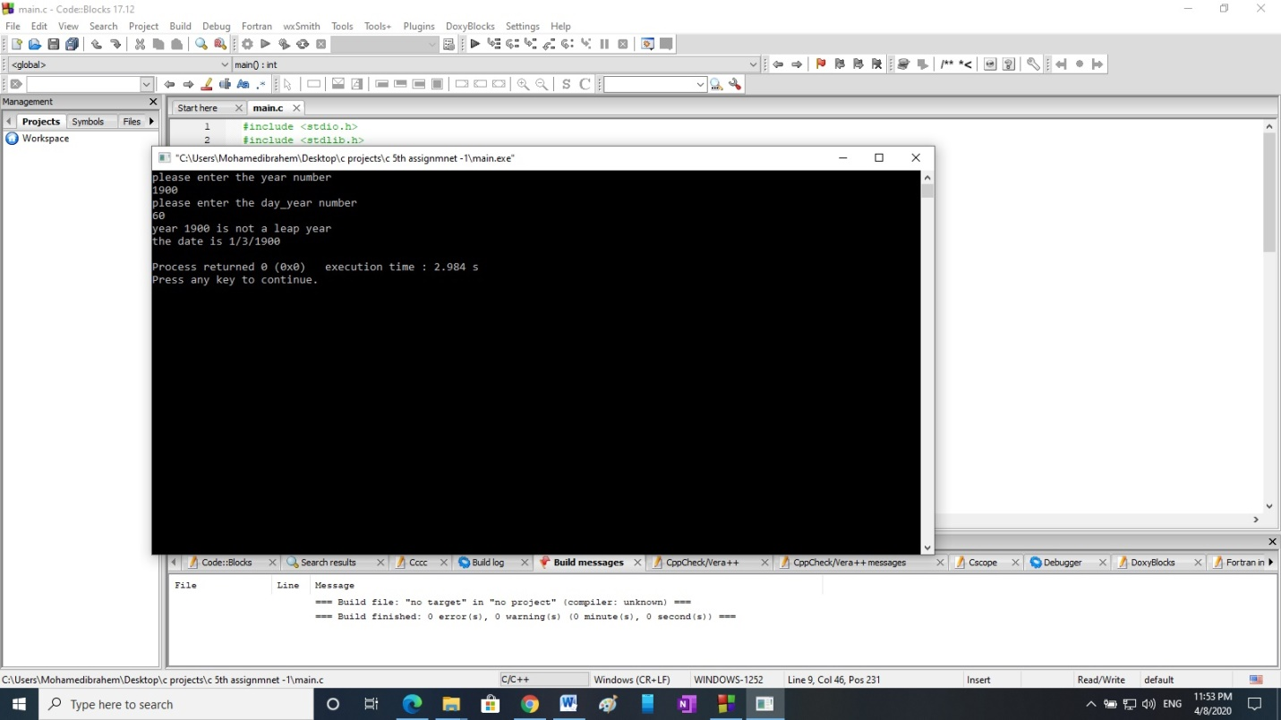

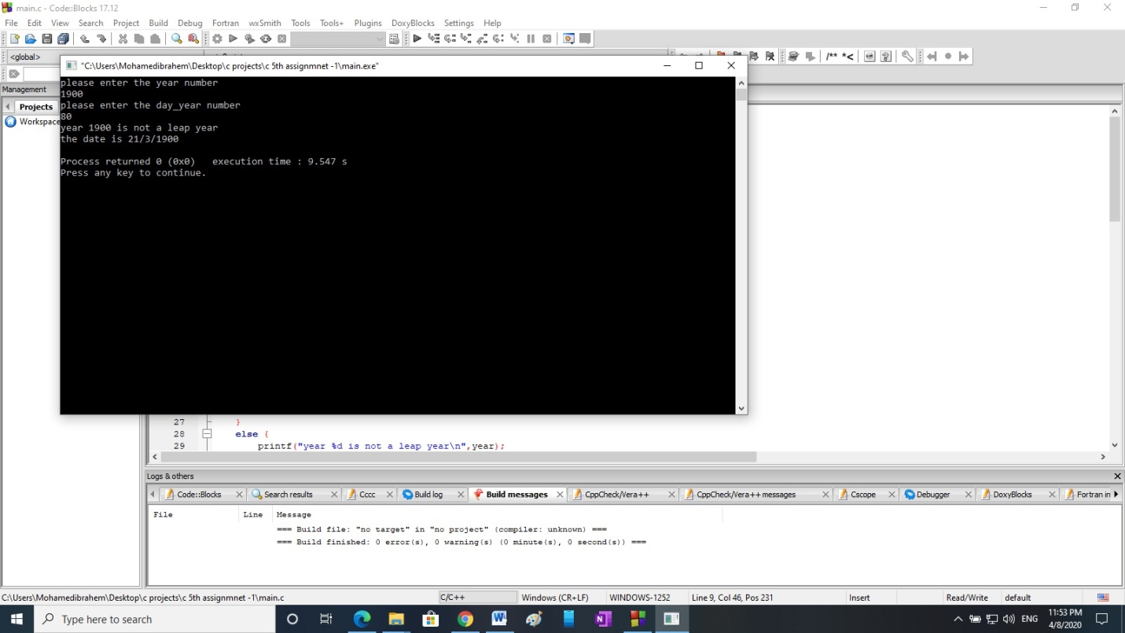

***Code2***

***#include <stdio.h>***

***#include <stdlib.h>***

***void unique(int arr[],int size,int *new_arr[],int *new_size);***

***int main()***

***{***

***int size=6;***

***int arr[6]={1,3,5,6,3,1};***

***int new_size=0;***

***int new_arr[]={};***

***unique(&arr[0],size,&new_arr[0],&new_size);***

***printf("new size = %d",new_size);***

***return 0;***

***}***

***void unique(int arr[],int size,int *new_arr[],int *new_size)***

***{***

***int o,k,j;***

***int c=0;***

***int size_new=0;***

***int arr_new[size];***

***for (o=0;o<=size;o++){***

***k=arr[o];***

***for (j=(o-1);j>=0;j--){***

***if (k==arr[j]){***

***c=5;***

***}***

***}***

***if (c==0){***

***arr_new[size_new]=k;***

***size_new++;***

***}***

***c=0;***

***}***

***for (int i=0;i<size_new;i++)***

***{***

***new_arr[i]=arr_new[i];***

***printf("in fn the new array = %d size_new=%d\n",new_arr[i],size_new);***

***}***

***\*new_size=size_new;***

***}***

